

FINAL REPORT

MINF UDL 20-21

Ubiquitous and Embedded Systems

**Team1**

Danillo Lange

Jeongyun Lee,

Ronnel Mattew

Index

1. Product Backlog Items
2. Sprint Diary

-1st sprint

-2nd sprint

-3rd sprint

-4th sprint

3. Final Project Conclusions

1. Product Backlog Items

PBI

|  |  |  |  |
| --- | --- | --- | --- |
| Task | TaskPoints | PIC * | Sprint |
| Components Background Knowledge | 3 | All | 1 |
| Prepare the IDE : ARD & ESP-01 | 4 | All | 1 |
| PrePare the IDE : R.Pi & ChibiOS | 3 | All | 1 |
| Define the checking/ test Process | 5 | Danillo | 2 |
| ESP-1 <-> Arduino Interation | 3 | Danillo | 2 |
| Data producer 1 Development | 3 | Yoon | 2 |
| Data producer 2 Development | 4 | Ron | 2 |
| 2nd Sprint Presentation | 2 | Yoon | 2 |
| How to -> LCD Screen | 2 | Ron | 3 |
| How to -> I2C protocol | 8 | Yoon /Danillo | 3 |
| How to -> PCF 8754 | 4 | Ron | 3 |
| R.Pi <-> Arduino Interation | 9 | Yoon / Danillo | 3 |
| 3rd Sprint Presentation | 2 | Danillo | 3 |
| Data log and Screen representation | 3 | Yoon | 4 |
| Ultrasonic <-> Led Bar Representation | 5 | Danillo | 4 |
| 4th Sprint Presentation | 2 | Ron | 4 |

User Stories

* Build a system to monitor some variables of a tank container.

**🡪Components Background Knowledge**

**🡪Prepare the IDE : ARD & ESP-01**

🡪**PrePare the IDE : R.Pi & ChibiOS**

🡪**Define the checking/ test Process**

* It is necessary to obtain the temperature and humidity of a tank container

**🡪 Data Producer 1 : ESP 01 + DHT 11 Sensor**

* It is necessary to obtain the chemical compound level of tank container

**🡪 Data producer 01 : ESP 01 + HC-SR04 Sensor**

* Sensor data must be sent to a remote controller.

**🡪 ESP01 – Arduino Integration**

Operator requires graphical representation of the temperature and humidity , obtained within the last 24h, in the controller.

🡪 **How to -> LCD Screen**

**🡪R.Pi <-> Arduino interaction**

**🡪**Data log and Screen representation

* Operator requires information of the current tank container level in real time and it must be shown in a led bar present in the controller

**🡪Utrasonic <-> LED bar Representation**

**🡪How to -> PCF 8754**

*PIC : Person in charge

1. 1. Sprint Dairy – 1st sprint

**1st sprint definition**

In this sprint, we figure out characteristics of each component and prepare proper environment for the project.

Related User Stories:

1. Build a system to monitor some variables of a tank container.
2. Acceptance criteria

Arduino and Raspberry Pi should be ready to connect with other components.

1. Related tasks :
   * 1. Components Background Knowledge **100%**
     2. Prepare the IDE : ARD & ESP-01 **80%**
     3. Prepare the IDE : R.Pi & ChibiOS **30%**

**Backlog task**

1. Components Background Knowledge Effort : 3 (Group Task)
2. Prepare the IDE : ARD & ESP-01 Effort : 4 (Group Task)
3. Prepare the IDE : R.Pi & ChibiOS Effort : 3 (Group Task)

**Percentage of Sprint completion**

1. Components Background Knowledge **100%**
2. Prepare the IDE : ARD & ESP-01 **80%**
3. Prepare the IDE : R.Pi & ChibiOS **30%**

**Sprint review / Sprint goal**

“In this sprint we managed to acquire some knowledge about the main components of the project (R.Pi and Arduino)”

1. 2 Sprint Dairy – 2nd sprint

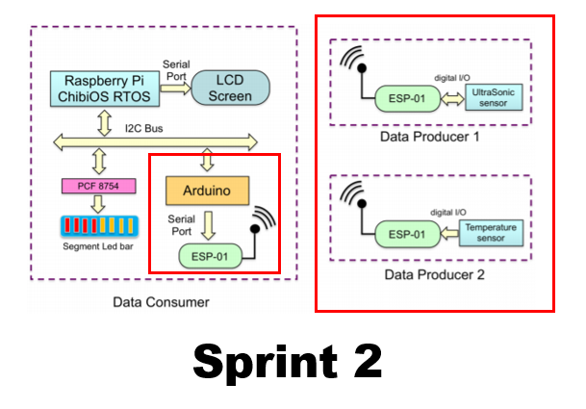

**2nd sprint definition**

“In this sprint the objective is to develop some of the core components of the project, like the sensors and the wireless senders and receiver to meet the requirements of some user stories.

i. Related User Stories:

1. Operator requires graphical representation of the temperature and humidity, obtained within the last 24h, in the controller.

a. Acceptance criteria:

i. The Temperature and Humidity must be shown in the LCD Screen

ii. The communication between the components using i2c must be well defined.

b. Related tasks:

1. How to -> LCD Screen
2. R.Pi <-> Arduino interaction

2. Operator requires information of the current tank container level in real time and it must be shown in a led bar present in the controller.

a. Acceptance criteria:

i. The LED Bar should represent the level compound

ii. The variables must be received inside the i2c system to distribute to each respective graphical representation

b. Related tasks:

i. How to -> I2C protocol

ii. How to -> PCF 8754

**Backlog task**

1. Prepare the IDE - R.Pi + ChibiOS 3 effort points (Group Task)
2. Define the checking/test process 5 effort points (Danillo)
3. ESP-01 <-> Arduino interaction 3 effort points (Danillo)
4. Data Producer 1 development 4 effort points (Yoon)
5. Data Producer 2 development 4 effort points (Ronnel)
6. Presentation Effort: 2 (Yoon)

**Percentage of Sprint completion**

1. Prepare the IDE - R.Pi + ChibiOS **100%**
2. Define the checking/test process **80%**
3. ESP-01 <-> Arduino interaction **100%**
4. Data Producer 1 development **100%**
5. Data Producer 2 development **100%**

**Sprint review / Sprint goal**

“The goal of this sprint was to develop some of the basic needs of data producing and receiving which will be necessary for the final project , by achieving it the group will be able to continue the development implementing new features in order to meet the requirements for the user stories.”

1. 3 Sprint Dairy – 3rd sprint

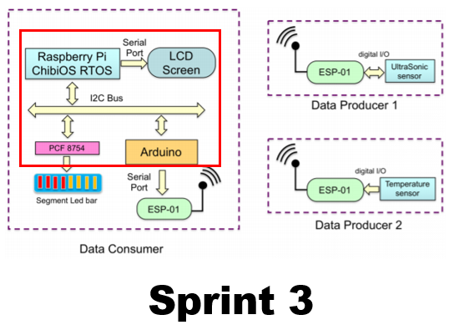

**3rd Sprint definition**

“The goal of this sprint is to develop some important features needed to the final project, such as graphical representation and interaction between the components of the main part of the project”

i. Related User Stories:

**1. Operator requires graphical representation of the temperature and humidity , obtained within the last 24h, in the controller.**

a. Acceptance criteria:

i. The Temperature and Humidity must be shown in the LCD Screen

ii. The communication between the components using i2c must be well defined.

b. Related tasks:

i. How to -> LCD Screen

ii. R.Pi <-> Arduino interaction

**2. Operator requires information of the current tank container level in real time and it must be shown in a led bar present in the controller.**

a. Acceptance criteria:

i. The LED Bar should represent the level compound

ii. The variables must be received inside the i2c system to distribute to each respective graphical representation

b. Related tasks:

i. How to -> I2C protocol

ii. How to -> PCF 8754

**Backlog tasks**

1. How to -> LCD Screen - Effort: 2 - (Ron)
2. How to -> I2C protocol - Effort: 8 - (Yoon/Danillo)
3. How to -> PCF 8754 - Effort: 4 - (Ron)
4. R.Pi <-> Arduino interaction - Effort: 9 - (Yoon/Danillo)
5. Presentation - Effort: 2 - (Danillo)

**Percentage of Sprint completion**

1. . How to -> LCD Screen - **100%**
2. How to -> I2C protocol - **100%**
3. How to -> PCF 8754 - **100%**
4. R.Pi <-> Arduino interaction - **100%**

**Sprint review / Sprint goal**

“The goal of this sprint was to research and fully understand the components included in the main project communication, such as the i2c communication, raspberry and LCD integration, so in that way we can in the next sprint implement all the knowledge and achieve the final graphical representation needed for the project.”

1. 4 Sprint Dairy – 4th sprint

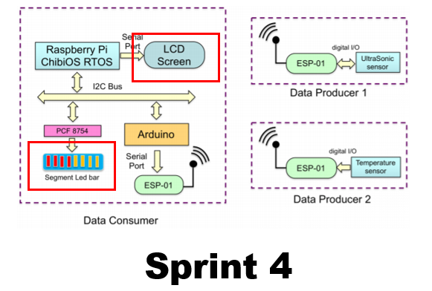

**Backlog tasks**

1. Data log and Screen representation 3 effort points Yoon
2. Ultrasonic <-> Led bar representation 5 effort points Danillo, Ron
3. Final Assembly 8 effort points (Group task)
4. Presentation 2 effort points Ron

**Sprint definition**

“The goal of this sprint is to develop the final layer of components of the project using the obtained knowledge, which consists of the LED Bar representation and the LCD Screen graphical representation.”

i. Related User Stories:

**1. Operator requires graphical representation of the temperature and humidity , obtained within the last 24h, in the controller**.

a. Acceptance criteria:

i. The Temperature and Humidity must be shown in the LCD Screen

ii. The graphic shown must draw a line of the temperature/humidity in relation of the time, for a period of 24 hours

b. Related tasks:

i. Data log and Screen representation

**2. Operator requires information of the current tank container level in real time and it must be shown in a led bar present in the controller.**

a. Acceptance criteria:

1. The LED Bar should represent the level compound
2. The variables must be received inside the i2c system to distribute to each respective graphical representation

b. Related tasks:

i. Ultrasonic <-> Led bar representation

**Percentage of Sprint completion**

1. Data log and Screen representation - **100%**
2. Ultrasonic <-> Led bar representation - **100%**
3. Final Assembly - **100%**

**Sprint review / Sprint goal**

“The goal of this sprint was to finally implement the last layer of the project which is the graphical representation to the final users. Design an easy to read screen with information is also in the priorities, for the LED segment bar we are considering it to reflect the actual state of measurements made by the distance sensor.

1. Final Project Conclusions
2. **Physical Device Knowledge**

Even if most of team members doesn’t have background knowledge about the Arduino and RaspberryPi, we could manage the project successfully. The project was a great experience for understanding the structure of physical devices. The datasheets of each components were helpful.

1. **Scrum Feedback**

Every Sprints would be more efficient if we can get scrum feedback. We could get the technical help and feedback from the professor. Otherwise, It was hard to get the opinion about the scrum managing during the sprint. Moreover, If we can share our opinion about the project with other teams and professor, the students will make more progress on project.

1. **Enough Spare Components**

The wires and pins can be broken easily. We suggest providing enough spare components just in case.

1. **Practical Resources**

As we mention above, most of students taking this subject didn’t have any experience or background knowledge. It was great that we checked the technical ability of students on the first session. With the provided sources, the practical sessions and references can be provided.

1. **Simple Evaluation Form**

After each sprint, we filled the evaluation form for each team and members. However, each query on the form were ambiguous and could cause the misunderstanding easily. So simple and clear questions can solve these problems.